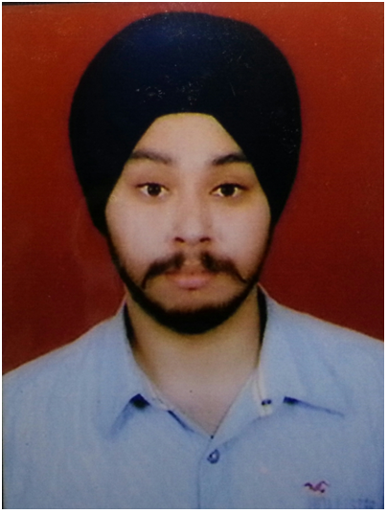

HARPREET SINGH
B-29/30 Badarpur Extension
New Delhi-110044, INDIA.
Telephone:91-9868561792 , 8802623572
Email : harpreet2feb1991@gmail.com

Current Job Description
- Working as an R&D design Engineer of Embedded Control Systems in Rebbon Isosystems Pvt ltd from Aug 2014 to till now.
Previous Job Description
- Have worked in DAKC, Mumbai – RCOM as an Asst. Manager for 6 months in DTH and IPTV backend services in both hardware and software research support .
- Having a work experience of 1.7yrs as an R&D engineer in Embedded systems design in RKS Electronics.
- Having a working Experience in Embedded Systems and Design(R&D) of 8 months from 3rd September 2011 to 23rd April 2012 under TICO(Techno Inovative and Creative Organisation).
- Having a work experience of 6 months as a R&D designing engineer of Embedded hardware from M-kris Electric.
Academic and Professional Educational Achievements
- Done B.Tech (Electronics & telecommunication) from IETE, Institute of Electronics & Telecommunication Engineering , 2012 batch ( CGPA - 7.55) , New Delhi.
- Done Advanced level diploma in Embedded systems and designs from TICO institute of Embedded technologies New Delhi , 2011 batch.
- RED HAT CERTIFIED ENGINEER(RHCE) course in LINUX from HCL CDC , New Delhi.
- Done 12th (C.B.S.E) with 62.7% (Science Stream - Non Medical) from Army Public School, New Delhi .
- Done 10th (C.B.S.E) with 73.2% from Army Public School , Dinjan cantt , Assam.
Skill Sets

- Knowledge of Embedded System Designs / Robotics.
- Knowledge of ARM PROCESSORS(ARM 7-LPC2129), ARM CORTEX M0+(ATsamd21j18a), ARM CORTEX M4 (STM32F303VC), PIC controllers(PIC16fxx series and PIC18fxx series), 8051 controllers(Atmel at89s52), ATTiny 2313,ATmega 8L, ATmega 16L ,ATmega 32A
- Knowledge of Mixed Signal Processors MSP430Gxx series(MSP430G2553).
- Knowledge of Embedded C And Assembly Language for Microcontrollers and microprocessors.
- Languages Known: C, Visual basics (IP),VB.net.
- Knowledge Of Real Time Operating Systems (RTOS).
- Knowledge of Linux operating system(Red Hat).

Training and Projects

- Trained on 8051 and 8052 based microcontroller - ATMEL AT89s52, At89c51
- Advanced versions of Atmel series – Attiny13y,ATTiny2313, Atmega8L, Atmega16L, Atmega32A.
- ARM 7 PROCESSORS - LPC 2129,
- PICCONTROLLERS - PIC18f4550,PIC16fxx.
- Mixed Signal Processor - MSP430G2553, MSP430G2123 .
- ARM CORTEX M4 - STM32F303VC
- ARM CORTEX M0+ - ATSAMD21J18a.

Projects while working under Rebbon Isosystems Pvt Ltd Electronics :
- Completed whole project on Sliding Door Automation, both hardware and software on Arm cortex M0+ based Microcontroller AtSAMD21j18a.
- Made Fixed DC to DC flyback and forward convertor with the same IC for 5volt/130 milliamps and 35 volt dc/130 milliamps from 220 volts AC by using Max5019Csa Current mode PWM IC.

Projects while working under R K S Electronics :
- Worked on vending machine, added extra features in the existing software.
- Made SMPS for providing 12/24 volt dc and 4 amps of current and provided the feature of short circuit protection.
- Made DC to DC convertor for 12/24 volt dc and 3 amps from 12 volts 300 amps of battery.

Projects while working under M-KRIS Electric :
- Star-Delta Delay Circuit using IC 4541 with Capacitive power supply.
- Protection Relay Circuit using PIC12f683.

Projects while working under Wipro Private Limited :
- Trained on Disaster recovery and Mangement.
- Made a Wndows Form Application(simulators) on logic gates ----Adder, subtractor, half adder, full adder circuits in VB.net .

Projects In analog Electronics :
- Made long duration timer.
- Made push to start timer.
- Made UP/DOWN counter.
- Power Supplies (Linear Single phase).
- Capacitive Power Supplies.
- Smps power supplies

Projects On Microcontroller(AT89s52) :
- Worked on DTMF & RF ID module technologies.
- Made a smart card access control system using RFID, which if card accepted asks for password.
- Multikey function using single key.
- Worked on Communnications Protocols : Serial Communination - RS232 , RS485 ,I2C protocol , SPI . And have theoretical knowledge of CAN bus Protocol and USB.
- Made a Real Time Clock(RTC) using DS1307 based on I2C protocol.
- Frequency Generation.
- Pulse Width Modulation(PWM).
- Analog to digital conversion.
- Worked on line follower Robot.

Projects On PIC Microcontroller(PIC18F4550) :
- Analog to digital conversion.
- RTC(Real time Clock).
- Protection Relay Circuit using PIC12f683.

Projects On ARM 7 TDMI Microprocessor(LPC 2129) :
- Worked on Development Board only.

Proj ects On ARM Cortex M4(STM32f303vct6) :
- Worked on Development Board.
- Worked on Graphical LCD.

Projects On LINUX REDhat :
- Installation of Linux & Partitioning.
- Knowledge of LVM and RAID Partitioning.
- Package installation for DNS Server,Yum Server,Apache server,FTP mail server,NIS server.
- Shell scripting.

Softwares Known:
- Assembler : 8051 IDE.
- Keil u vision3 C compiler : AT89s52.
- CCS C Compiler: PIC18f4550.
- Keil u vision 4 C Compiler: ARM7TDMI - LPC2129 and Arm cortex M4- STM32F303VC
- Proteus
- Protel- PCB designing

Hobbies

- playing outdoor games.
- making projects.
- Photography.

Personal Details

Father's Name : Mr. Sohan Singh.
Date of Birth : 09th feb, 1991
Mother's Name : Mrs. Lakhbir kaur.
Brother's Name : Mr. Gurjit singh.
Languages known : English, Hindi & Punjab.
Marital Status : Unmarried.
Passport No. : H9616790
Pan card No. : EFJPS9261H

Personal Statement

To work with a professionally managed company which offers me the ambience to perform under challenging environment and opportunities to learn and grow.

(Harpreet Singh)

